Adding Kurzweil 3000 Read the Web as an
Extension on Chrome

1. Be sure you have the Chrome browser installed.

2. Locate the Google Search field on the Chrome browser and search for the Chrome Web Store.

3. Click the Chrome Web Store link. The Web Store is displayed.

4. Click Extensions. In the Search box type Kurzweil 3000. The results window displays Kurzweil 3000 Read the Web.

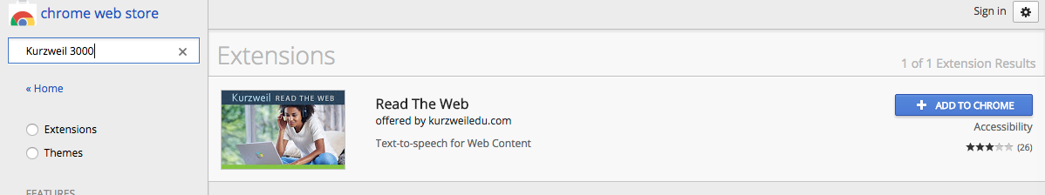
5. Click the blue +ADD TO CHROME button. A confirmation window is displayed.
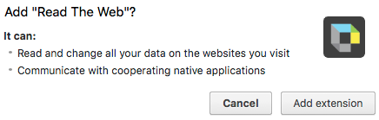
6. Click the Add extension button. An instruction window is displayed.


7. Log into the Kurzweil 3000 Read the Web toolbar.

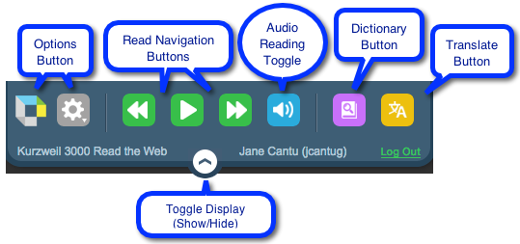
8. Your Read the Web Toolbar is opened and ready to use.

