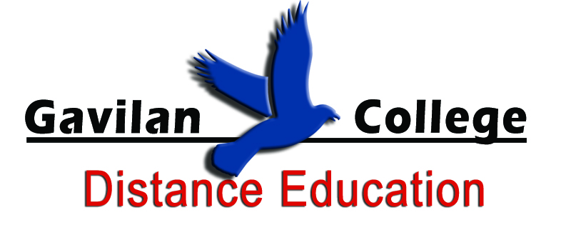
Distance Education Program
Master Plan
Distance Education Committee
2013

This document serves as a guide for supporting initiatives that have been identified and developed through our Technology Master Plan, the Strategic Plan, and the Educational Master Plan, as well as through our Distance Education Best Practices document, that will be implemented to best support the overall vision of the campus.

Table of Contents
Mission Statement 3
Program Goals 3
Purpose of Plan 3
Introduction 4
Background 5
Program Development - Planning, Implementation and Evaluation 6
Planning Cycle 6
Assessment 6
Distance Learning Enrollment 7
Distance Education Master Plan Initiatives 7
Program Level Outcomes/Strategies 7
Objectives (1-3 years) 8
Milestones (3-5 years) 8
Appendix E: Access Campus Planning Documents 10
LEADERSHIP: Distance Education Coordinator 10

Mission Statement
In an environment that cultivates creativity, stimulates curiosity and emphasizes student learning, Gavilan College serves its community by providing high-quality educational and support services that prepare students for transfer, technical and public service careers, life-long learning and participation in a diverse global society. The basis for each and every plan developed by the college is to provide the guidelines necessary to achieve Gavilan College’s mission. (http://www.gavilan.edu/aboutUs.html)
The Mission of the Gavilan College Distance Education Program is to provide the highest quality instruction and support services that are accessible and responsive to the learning needs of its communities with courses, certificates, and degree programs through distance education. The program will also support future program development through collaboration and innovation with the community.

Program Goals
Goals:
- Encourage faculty and departments to utilize forms of distance education to enhance their curriculum and course offerings.
- Support distance education training and professional development needs of faculty and staff
- Support technical needs of faculty/students for distance education.
- Expand alternative delivery formats to meet the needs of our population and develop programs and courses as resources are available
- Research, analyze, and recommend distance education policy and procedures to senate and other shared governance committees and departments as needed.
- Promote distance education as an alternative form of delivery as a solution to scheduling needs and classroom space.

Purpose of Plan
The Distance Education Plan is meant to be a guide for supporting initiatives that have been identified and developed through our Technology Master Plan, the Strategic Plan, and the Educational Master Plan, as well as through our Distance Education Best Practices document, that will be implemented to best support the overall vision of the campus. This plan will outline and identify initiatives necessary to support distance learning at Gavilan College. This Plan will be reviewed and updated annually with the input from the Distance Education Committee. Revisions of this document will be performed as necessary based on major revisions of dependent documents, such as the Technology Master Plan, Educational Master Plan, Strategic Plan, and/or Mission.

Introduction
In the fall of 2001, Gavilan College distance educators gathered and discussed goals and objectives for the new distance education program. Many of these goals have been accomplished.
The college has followed the national trend of continual growth in the number of online course offerings and of students enrolled in these courses. The last few years have also seen a demand for all instructors to have an online presence and to make course materials and resources available via the online format.
Because of this growth, the college established the Distance Education Committee, which is tasked with utilizing strategic thinking and coordinated action to facilitate the growth of our distance education program. The current Distance Education Committee, formed in the fall 2008 has been tasked with preparing this Plan, as well as written recommendations for guidelines and best practices for the College’s Distance Education Program. The membership of this committee includes faculty, support staff, and administration.
To date the Distance Education department and/or the committee has completed the following:
- Facilitated program growth from 3 fully online courses to 59 fully online courses and a total of 249, online, hybrid, supplemental, language labs, committees and departments and GECA AP classes.
- Developed the concept of a Teaching and Learning Center (TLC) and moved the Distance Education Program and Staff Resource Center under one physical location, into the new Teaching and Learning Center, centrally located on campus in the Library.
- Provided an online course shell for every course offered, every semester, to every instructor.
- Developed and streamlined technical processes for login procedures
- Developed and streamlined faculty course request process
- Joined a consortium with 2 other local colleges, Monterey Peninsula College and Cal State University Monterey Bay for the purpose of switching learning management systems (LMS) from Etudes to Moodle.
- Hired one new FT faculty member to coordinate the Distance Ed program.
- Successfully migrated the college over to Moodle and trained instructors and support students through transition
- Provided staff and faculty development in the SRC (now TLC)

Background
Distance education has been utilized for many years at Gavilan College. For several years, Gavilan faculty have been developing and teaching online courses. In 1999, the Distance Education Program at Gavilan College began. Starting with 3 classes using static web pages, the demand for education delivered in this format grew. In 2001, the College hired a faculty member to coordinate and encourage instructors to develop their courses using this delivery method. These early adopters were responsible for finding and implementing appropriate technology tools to create and manage their online courses. As a result of the success of these early online courses, student demand for online education and faculty demand for technology to facilitate their online teaching has increased.
The Distance Education Program at Gavilan College operates under the umbrella of the Library Department. The Program is responsible for the technology, guidance, training, and support needed for the instructional program to deliver curriculum, asynchronously or synchronously, in an online environment, videoconferencing environment or other distance learning format for Gavilan Community College. This includes supporting the technical needs of distance learners and instructors at main campus and off-sites (Gilroy, Hollister and Morgan Hill) as well as any other geographical location that our students and faculty may be accessing our online environment from.
The program hosts online courses at http://ilearn.gavilan.edu and has a resource center for students and faculty at http://www.gavilan.edu/disted. In addition, the program offers training to teach online using a variety of technologies and resources, orientations to online learning for students, and providing an instructional technology in the Teaching and Learning Center for faculty and staff. Currently, the program is staffed with one full time Distance Education Coordinator and one part-time Distance Education Trainer.
The Distance Education Program maintains excellent working partnerships with other instructional and student service departments on campus, as well as other local colleges and universities, including CSU campuses, San Jose State and Monterey Bay, and Monterey Peninsula College and Hartnell College.

Program Development - Planning, Implementation and Evaluation

Planning Cycle
Every 3-5 years (Improvement, Assessment, and Analysis):
- Program Review (Incorporate IEC, feedback from surveys, DE committee feedback, statistical analysis of retention/success rates, comparison with state levels, and other program offerings)
Annually (Improvement, Assessment, and Analysis):
- Program Planning
- Budget Requests
- Budget Allocation
- Implementation
- Strategic Planning
Assessment
Each semester student and faculty satisfaction surveys (created by state model, refined in house and given out to all online participants through iLearn) will be conducted and results reported to the Distance Education Committee. The D.E. Committee will also study success/retention rates in online delivery methods and compare with face-to-face delivery rates, analyze socioeconomically reports, and other measurements in collaboration with the institutional researcher for further analysis and planning for improvement. At the end of the one year period defined in this plan, a summative evaluation of the distance education programs will be generated and will be used as the basis for the next years planning cycle. This process will also be repeated at the end of the 5 year period for long term goal planning.

Distance Learning Enrollment
Diagram 1: Full time equivalent students (FTES) in distance education courses over time.
This diagram reflects the tremendous growth of FTES in distance education.
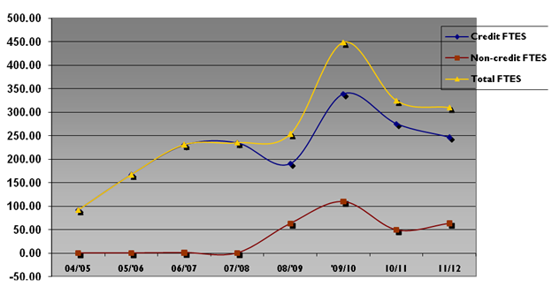

Outcomes/Objectives

Program Level Outcomes (In program review)
- DE program will strive to meet or do better than the state student success | - Offer more staff development for instructors to apply early outreach to students at risk of failing course.
- DE program will strive to meet or do better than the state student retention rate for online courses | - Offer staff development for instructors in orienting their students, more in person/ online orientations for students
- Students will feel technology used in their DE course was helpful | - Offer staff development for instructors Introduce newest technologies
- Students will have the same or more interaction with their instructor in the online format that they would have had in class | - Offer staff development for instructors in effective asynchronous communication methods
- Students will feel the instructors presentation and course materials were helpful | - Offer staff development for instructors in best practices in online course development
- Faculty will be satisfied/very satisfied with the reliability of the technology and technical support offered by the DE program | - Continue to work with MIS and CSUMB to improve technical components of DE program
- Faculty will be satisfied/very satisfied with their DE experience as compared with their F2F classroom experience (Ability to support necessary instructional strategies) | - Staff development and continual improvement of technical components

Objectives 1-3 years (In Program Review)
Objective | Estimated cost | Staffing
- Develop and deliver an in-house online teacher certification program and refresher course for seasoned online instructors. | Staff Time/Part-time instructor | Development: DE Coordinator Delivery: TLC Instructor
- Recommend to the Faculty Senate and other shared governance groups that instructors teaching on-line, who have not already received certification from other recommended sources, become certified. | Staff Time | DE Coordinator/DE Committee
- Survey faculty to decide future develop of programs/certificates in online delivery formats | Staff time | DE Committee
- Work with the Distance Education Committee, Department Chairs and Curriculum Committee, to facilitate the development of distance and web based classes, with an emphasis on developing a fully online A.S degree in CSIS. | Staff Time | DE Coordinator/DE Committee
- Seek approval and fill a faculty position for Instructional Technologist/Distance Education Trainer full time to oversee TLC and work with D.E. program. | $60,000 | Convert part-time existing position to full time
- Conduct faculty and student evaluations of Distance Education programs to measure the impact on enrollment and retention, faculty and student satisfaction and technical reliability. | Staff Time | DE Coordinator
- Working with the librarians, develop modules based on information competency goals and to provide resources and tools to address those goals within the curriculum. | Staff Time | DE Coordinator/Librarian/TLC Instructor
- In collaboration with the Curriculum Committee identify programs needing the substantive change process completed and develop a process to identify future course approvals triggering substantive change process. | Staff time | DE Coordinator/Curriculum Committee

Objectives 3-5 years
Objective | Estimated cost | Staffing
- Evaluate and develop other types of distance education delivery formats (video conferencing, synchronous delivery), focusing on course development using this type of delivery at satellite campuses. | Staff Time  Potential Costs up to $50,000 | DE Coordinator/DE Committee
- Evaluate, compare and recommend a learning management system for online course delivery. | Staff Time | DE Coordinator/DE Committee

Recommendations:
- All Distance Education classes and programs will meet all program and accreditation requirements for distance and distributed learning.
- All Distance based courses will include a thorough assessment of the impact of technology on student learning.
- The D.E. program will work with MIS, as well as CSUMB to coordinate the provision of appropriate hardware and software tools for distance and distributed course development and delivery, including adequate security and student authentication tools
- The D.E. program will seek to assure that services to distance students will parallel those available to on- campus students (i.e. library resources, orientation to technology, admissions, financial aid, advising, registration, access to academic support programs, career services, etc.)
- The D.E. program will maintain an emphasis on establishing required or general education courses and the delivery of degree completion or certificate programs

Appendix E: Access Campus Planning Documents
- Strategic Plan: http://www.gavilan.edu/master/
- Technology Master Plan: http://www.gavilan.edu/tech_plan/Tech_Master_Plan.pdf
Initiatives
http://www.gavilan.edu/tech_plan/Tech_Master_Plan.pdf page 11

LEADERSHIP: Distance Education Coordinator
INITIATIVE | ESTIMATED COST | STATUS
- Provide training, awareness and support for faculty who want to engage in distance learning instruction. | Staff Time | Implementation is  on-going
- Provide Course Management System (CMS) technical support for faculty and students. | Staff Time | Implementation is on-going
- Look at options for shared instruction via video conferencing/web enhanced delivery. | $50,000 | Planning
- Define the mission and goals and maintain Best Practices in Distance Education document to provide and ensure quality courses for the Distance Education program. | Staff Time | Planning
- Ensure access for students with disabilities to courses delivered in distance education formats. | Staff Time | On-going

- Educational Master Plan: www.gavilan.edu/strategic_plans/Gavilan_StrategicPlan_2011_2016.pdf

