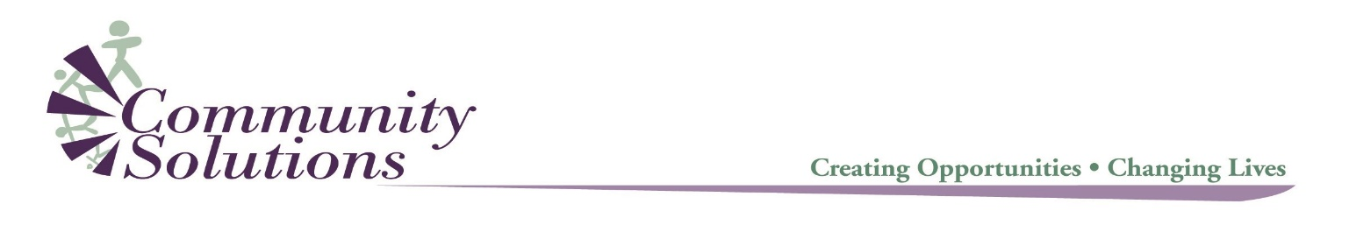



Virtual Mindfulness Matters Sessions

During this challenging time, we know that connection and mindfulness are so important to our physical and mental health. Join us for these 30- minute weekly sessions to connect, breathe and take care of ourselves.

Mondays 9-9:30am
Guided Mindfulness hosted by Lisa Colliss
Click here to join via Zoom at the scheduled time: https://zoom.us/j/107657241

Wednesdays 12-12:30pm
Guided Mindfulness hosted by Lisa Colliss
Click here to join via Zoom at the scheduled time: https://zoom.us/j/110188432

Fridays 2-2:30pm
Mindful Movement hosted by Dora Shalts-Lastra
Click here to join via Zoom at the scheduled time: https://zoom.us/j/948166911

