CRN# | COURSE# | COURSE TITLE | ROOM | INSTRUCTOR | Days | Time Begin
80705 | ESL 702A | ESL CITIZENSHIP | GILROY – CDC 110 | SARA AVILA | MW | 6:00-8:10pm
80284 | ESL 702A | ESL CITIZENSHIP | ONLINE | DAVID MCMULLEN | TR | 7:00-8:30pm
80730 | ESL 775 | ESL LITERACY 1 | ONLINE | MIRIAM VARGAS | MTWR | 6:00-8:50pm
80719 | ESL 784 | ESL LIFESKILLS 1A | GILROY- HU 104 | SHEILA WILLIAMS | MTWRF | 8:10am-12:00pm
80718 | ESL 784 | ESL LIFEKILLS 1A | HOLLISTER  ROOM 1 | ANGELICA ZAVALA | MTWRF | 9:10am-2:00pm
80717 | ESL 784 | ESL LIFEKILLS 1A | ONLINE | LYZETTE GUZMAN | MTWR | 9:00am-12:35pm
80716 | ESL 784 | ESL LIFESKILLS 1A | ONLINE | JESUS VILLICANA | MTWR | 6:00-9:35pm
80720 | ESL 785 | ESL LIFESKILLS 1B | ONLINE | JESUS VILLICANA | MTWR | 9:00am-12:35pm
80722 | ESL785 | ESL LIFESKILLS 1B | GILROY- HU 104 | JOHN HOWELL | MTWR | 4:45-9:45pm
80721 | ESL 785 | ESL LIFESKILLS 1B | ONLINE | PATRICIA CLAROS | MTWR | 6:00-9:35pm
80724 | ESL 786 | ESL LIFESKILLS 2A | ONLINE | MARTIN RODRIGUEZ | MTWR | 9:00am-12:35pm
80739 | ESL 786 | ESL LIFESKILLS 2A | GILROY- HU 105 | RAQUEL RODRIGUEZ | MTWR | 6:00-9:35pm
80723 | ESL 786 | ESL LIFESKILLS 2A | ONLINE | ELIF KONUS | MTWR | 6:00-9:35pm
80726 | ESL 787 | ESL LIFESKILLS 2B | ONLINE | HANDE YILDIZ | MTWR | 9:00am-12:35pm
80725 | ESL 787 | ESL LIFESKILLS 2B | ONLINE | KIMBERLY PORTILLO | MTWR | 6:00-9:35pm
80712 | ESL 744 | CULTURE THROUGH FILM | ONLINE | KAREN DEIHL | TWR | 9:00am-12:10pm
80713 | ESL 744 | CULTURE THROUGH FILM | ONLINE | CRAIG SANDERS | MWF | 6:00-9:10pm
80715 | ESL 764 | ADV GRAMMAR | ONLINE | HANDE YILDIZ | MWF | 6:00-9:10pm
80039 | ESL 756 | HSE/GED PREPARATION  (SPANISH) | HOLLISTER  ROOM 4 | MARCELA SERRANO | SAT | 8:30am-12:00pm 1:05-5:10pm
80703 | ENGL 756 | HSE/GED PREPARATION  (SPANISH) | ONLINE | ETHEL SANDOVAL | TR | 6:00-9:10pm
80704 | ENGL 756 | HSE/GED PREPARATION  (SPANISH) | ONLINE | MARCELA SERRANO | MW | 6:00-9:10pm
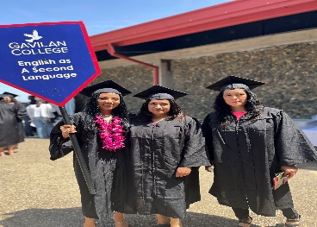
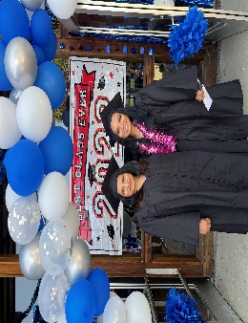
Gavilan College Continuing ED
Free/Gratis
Summer 2023 Classes (esl,ged, and citizenship)
Classes Begin: June 12th – July 21st

FOR MORE INFORMATION PLEASE CALL: (408)465-9520 & (408)852-2824
www.gavilan.edu/cont-ed
http://aces.gavilan.edu

FOR MORE INFORMATION PLEASE CALL: (408)852-2824
www.gavilan.edu/noncredit
http://aces.gavilan.edu


FOR MORE INFORMATION PLEASE CALL: (408)659-4025
www.gavilan.edu/cont-ed
http://aces.gavilan.edu

