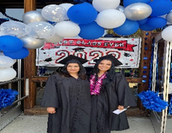
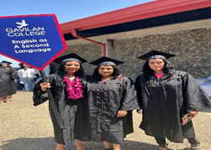
Gavilan College Continuing ED
Summer 2023 FREE Computer class
Clases de Computación GRATIS
Classes Begin: June – July 21st

CRN# | COURSE# | COURSE TITLE | ROOM# | INSTRUCTOR | DAYS | Time Begin | DATES
80709 | ESL 706 | COMPUTER-INTERNET BASICS | ONLINE | HANDE YILDIZ | TR | 6:00-9:10pm | 6/13-6/20
80710 | ESL 707 | PRESENTATION BASICS | ONLINE | HANDE YILDIZ | TR | 6:00-9:10pm | 6/22-6/29
80711 | ESL 710 | WORD PROCESSING BASIC | ONLINE | HANDE YILDIZ | TR | 6:00-9:10pm | 7/6-7/13
FOR MORE INFORMATION PLEASE CALL: (408)465-9520 & (408)852-2824
www.gavilan.edu/cont-ed
http://aces.gavilan.edu

