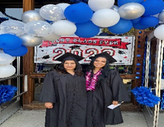
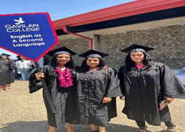
Gavilan College Continuing ED
Pre-Summer 2023 FREE Computer class
Clases de Computación GRATIS
Classes Begin: June 5th – 8th

CRN# | COURSE# | COURSE TITLE | ROOM# | INSTRUCTOR | DAYS | Time Begin | DATES
80706 | ESL 706 | COMPUTER  INTERNET BASICS | GILROY BU 119 | SHEILA WILLIAMS | MTWR | 6:00-8:10pm | 6/5-6/8
80708 | ESL 706 | COMPUTER INTERNET BASICS | HOLLISTER ROOM# 3 | MARTIN RODRIGUEZ | MTWR | 6:00-8:10pm | 6/5-6/8
FOR MORE INFORMATION PLEASE CALL: (408)465-9520 & (408)852-2824
www.gavilan.edu/cont-ed
http://aces.gavilan.edu

