I think the trick is to make sure the folder you are adding content to is the color light blue: Right click on it and click ‘view’.
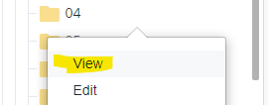

Notice how 04 is now blue.

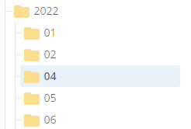
Click add content.



Click Default

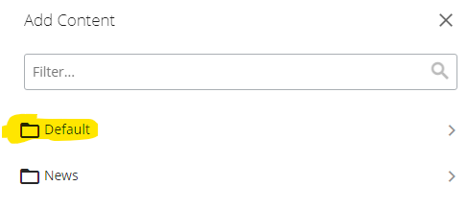

Then click File

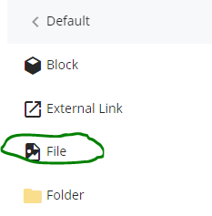

Then just drag your files here, it names them automatically.

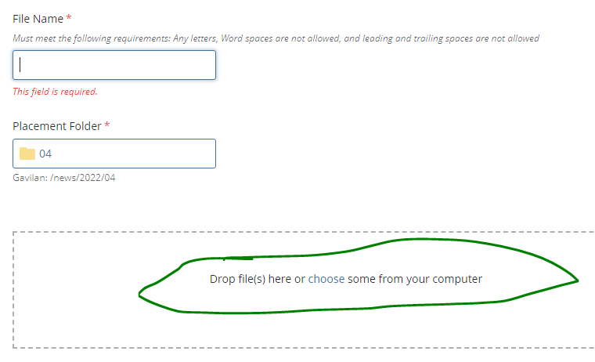

If the title of the document has blank spaces in it , the CMS will complain. You can fix it by clicking on the ‘use the suggested name’.

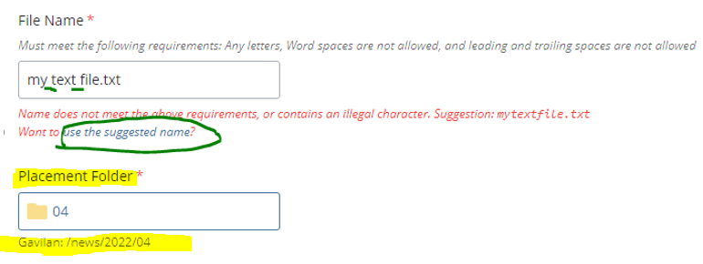

You can see the ‘Placement’ of your document ‘news/2022/04

Then click Preview Draft and Submit if it looks correct.

