Add a new page
Go to the folder where you would like the page to live in and right click and choose ‘view’. For example, I am adding a page to counseling so I right-click counseling and choose ‘view’.

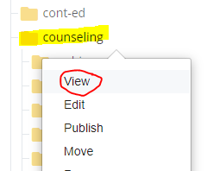

You want the folder to be turn blue like this:


Now click the red button Add Content.

Then click Add Content


And choose ‘Standard Page’
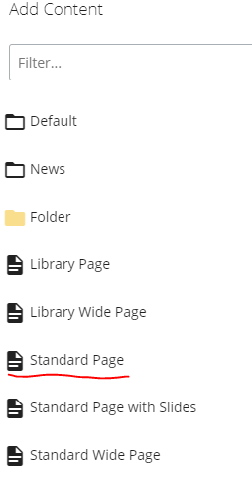

Add the Page Name, all lower case with no spaces. This is what the Internet uses as the name. (www.gavilan.edu/counseling/my_page_name.php)

Also add the display name, title and description.
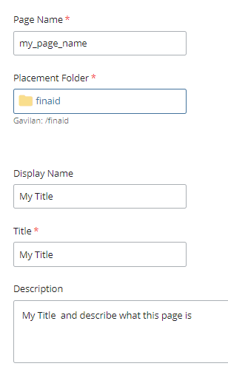

Click Preview Draft and then Submit.


Add a comment regarding your changes then click Check Content & Save.
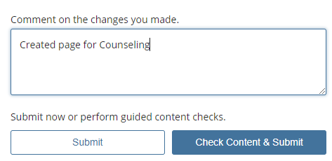

That’s it! You created a new page and it is available for editing.

