
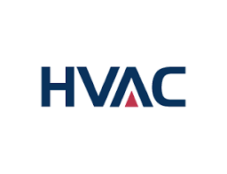

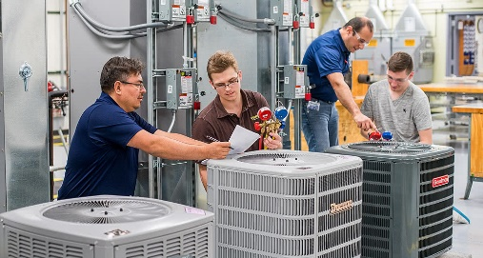

Heating, Ventilation, and Air Conditioning
Associate in Science or Certificate of Achievement

HVAC Wages
The median wage in 2022 for Heating/Air Conditioning and Refrigeration Workers in California is $61,738 annually, or $29.69 hourly.

Program Description
This degree is designed to prepare students to enter the Heating, Air Conditioning, and Refrigeration Technology field. Students receiving the certificate will have the knowledge and skills essential for employment in a variety of careers, including AC Technicians, Heating Technicians, Refrigeration Technicians, HVAC Mechanics, and HVAC Installers.

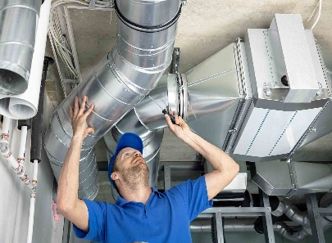
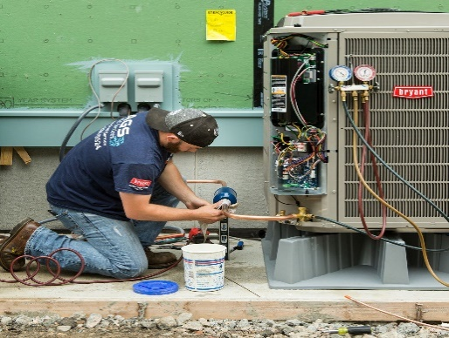

www.gavilan.edu/CareerEd

Jessica Weiler
Career Education Counselor
jweiler@gavilan.edu

Program Requirements (24 UNITS)

HVAC 201 Basic Electrical Theory . . . . . . . . . . . . 4 units
HVAC 202 Basic Refrigeration . . . . . . . . . . . . . . . 4 units
HVAC 203 Heating Systems . . . . . . . . . . . . . . . . .4 units
HVAC 204 Air-Conditioning and Heat Pumps . . . .4 units
HVAC 205 Commercial Refrig. and Ice Machines 4 units
HVAC 206 HVAC Controls . . . . . . . . . . . . . . . . . . 4 units

HVAC Job Outlook
As the population and number of buildings increase, so does the demand for residential, commercial, and industrial climate-control systems. The complexity of today’s climate control systems increases the possibility that equipment may malfunction, creating more employment opportunities for Technicians.

