
iLearn Studio Quickstart
The link to Studio should always be visible on the left-hand navigation. From here you can:
- See all your videos
- Record a new one
- Upload a video file from your computer.

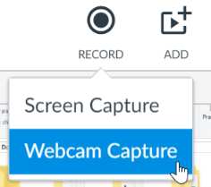
You can record from the camera, (Webcam) or make a video of your computer’s screen (Screen Capture)

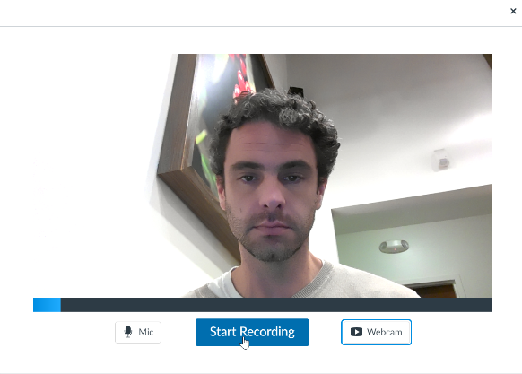
Record & Save a Video
In general, you can follow the prompts to record and save your video.
Click the Start Recording button to begin.
When finished, you’ll be asked for a name (which is only visible to you, the teacher,) and it’ll upload back to iLearn.
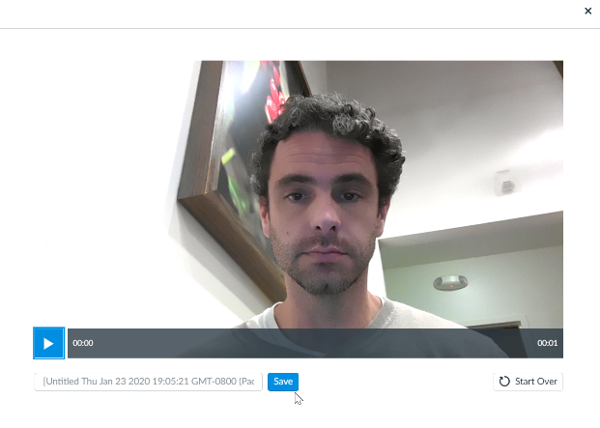

Screen Capture
Screen Capture will make a recording of your screen. Use it if you want to, for example, narrate a Powerpoint presentation.

This is the Screen Capture. It will record a portion of your screen, in any program you wish to run.

You can adjust the dotted box to the area you want to record.
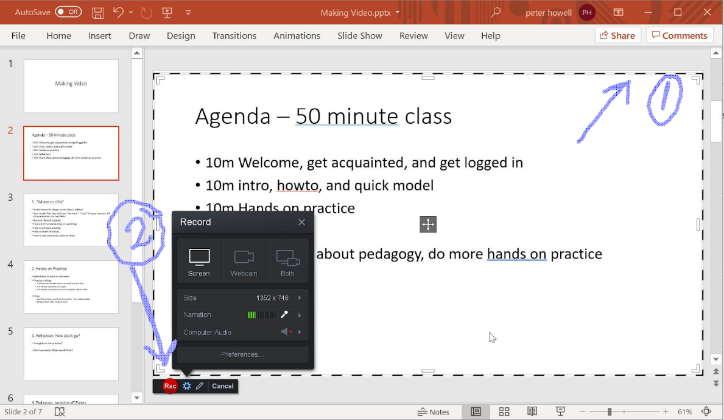

Making Captions
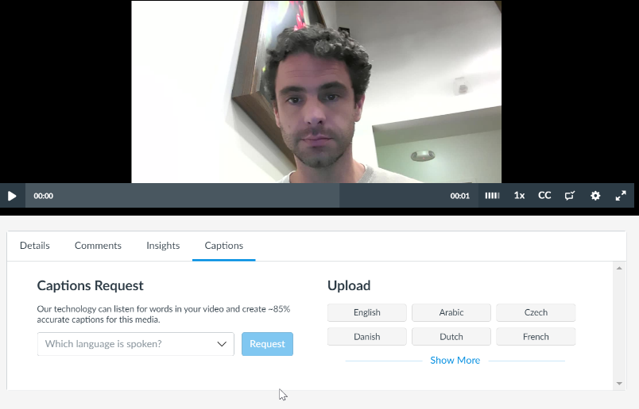
After you’ve recorded the video, go to its page and the Captions tag. Click the Request button.
Return in 24 hours and edit/post the captions.

Embed it into a Class
Now you’ll leave the “Studio” behind and go to your class. Find the place you want to put it. Often this will be a new page. You can embed a video into a page, an assignment, a forum post, an announcement… anywhere you see the standard “text editor” tool in iLearn. Your students can do this as well!

Step 1: Click that little blue V
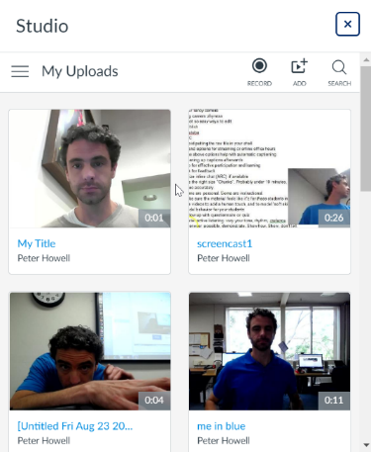
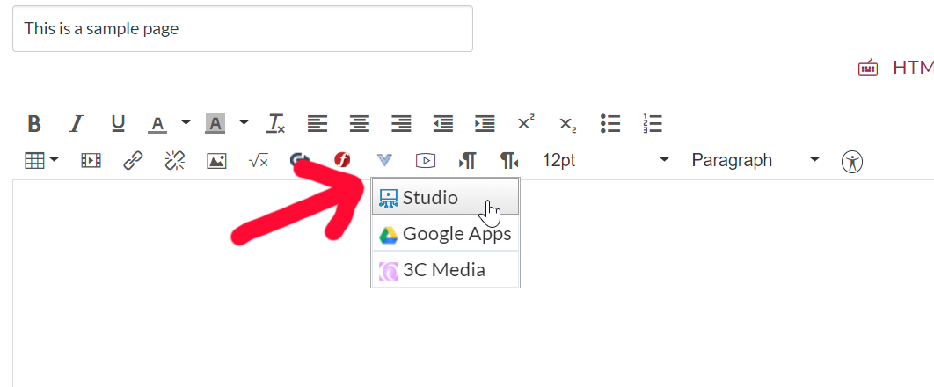
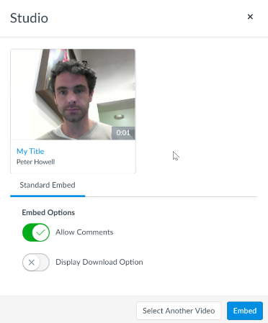
Step 2: Pick out a video by clicking on it.

Step 3: Choose if you want comments.

What About Editing?
Editing your video means that you'll cut and move parts of the footage around. Remove your mistakes, and re-arrange things. You can also add titles, graphics, and other effects.

While this is powerful, it is also complex and hugely time-consuming. It is worth it, but it is not necessary for what we want to do. If you can keep your presentation tight and do it right on camera, you will save yourself hours of time. You'll also benefit from doing the video more than once -- rehearsing it and possibly re-recording it until you like the results.

If you're ready to take the plunge into editing, you have options galore, ranging from simple to Hollywood level. Some of the more common ones are:

- iMovie on the Mac, and Windows Movie Maker on Windows. These are provided by your respective computers, are free, and are a good entry-level tool to get started editing and adding titles and graphics.
- An online service. There are many of these, some through the web, and some via an app on your phone. Youtube has a decent tool for doing basic editing.
- Adobe Premier. If you use the Adobe suite, you may already have a copy of premier. It will give you maximum flexibility

Recommendation for editing: Skip it. Use your time to outline your presentation, practice, rehearse, and do multiple takes. It will be faster and give better results.

What about Captions or a Transcript?
They are a requirement. It must be done. Skipping this step opens the school up for some very bad risks:

- A lawsuit, costing tens or hundreds of thousands of dollars. (This is happening right now to some schools)
- Attention from the State and the Accreditation team. This is a Very Bad Thing

The law, and common decency, insists that we provide closed captioning for each video we use in a class. Fortunately, this is much easier to do now.

Both of our most common tools will create a 90% accurate transcript automatically. Youtube and iLearn Studio will generate captions automatically. You do need to find the right button to click to request this. You will need to go in and correct that last 10%.

Overview of Video Services Available to Us

 | What's it for? | Audience | Live? | Sample
Zoom  Webinar / Meeting | Broadcast events, lectures, meetings to a wide audience.  Video, powerpoint, or screensharing.  Hold videoconference / meetings with both local and remote participants. | Students, Staff, and general public. | Yes. Optionally record and share meetings. | 
Studio | Upload and display videos anywhere in iLearn.  Ask and answer comments within the video timeline.  See detailed view/participation statistics. | Anyone inside of ilearn (only registered users) | No. | 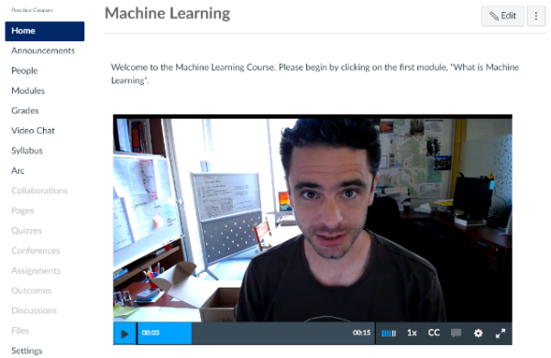
Cranium Cafe | Virtual office hours or virtual classroom.  One-on-one or small group  Collaboration or presentation  Virtual whiteboard, webcam, or screensharing. | Anyone inside of ilearn (only registered users) | Yes, optionally record and share meetings. | 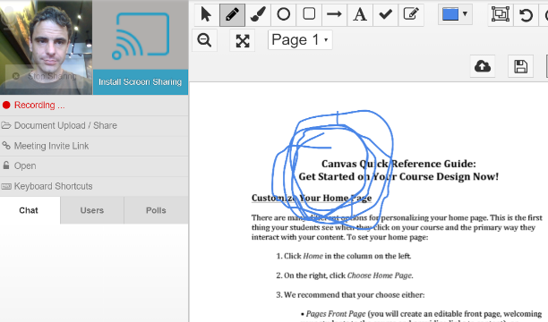
Youtube & Youtube Live | Commercial video host, owned by Google.  Stores and delivers your videos.  May insert advertisements. | Videos can be public, private, or only shown to someone who has the URL. | Yes. Live broadcasts are automatically recorded and can be made public afterwards. | 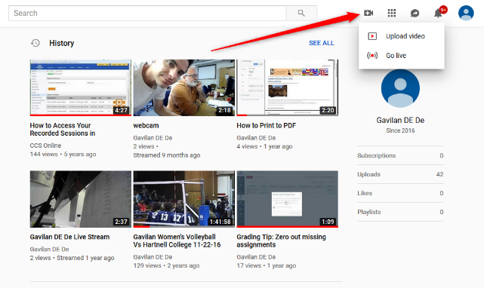

The Equipment
The first question is what you are going to use to record. These are the most common answers:

Smartphone   | Laptop camera or webcam 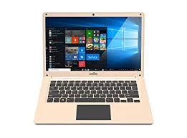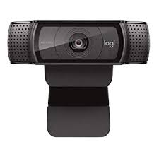 | Handheld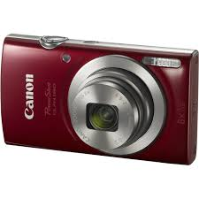
You probably have one.  You can record directly into iLearn using the Canvas App and Studio.  You can go to iLearn on your phone and upload from it.  Medium to good quality. | Simplest. Medium to good quality.  Use iLearn Studio to record directly into your account. | If you have one, it will probably be high quality.  Use an SD card or a USB cable to bring it to your computer.

Recommended recording device: Your laptop's camera, or buy a Logitech c970. (Approx $90)

Another good option is to do screencasting. With this option, you are going to record your screen (or a part of it) and your voice. You could, for example, run through a powerpoint slideshow, explaining it, or you could visit web pages. You can also explain some software or some procedure that they are learning about computers.

There's a variety of software that will do this. Our iLearn's built-in software, Studio, will let you do this. On a PC, sometimes I use a free program called Screenpresso.

Recommend screencasting software: The built-in video tool in iLearn: Studio.

Video Workshop Outline
The students' most requested change is to move away from text-heavy lectures and towards video and multimedia. We'll get hands-on practice with all the steps in the pipeline, and explore different ways to make it simple for the beginner, or fancy for the expert. Everyone is welcome!

- Overview of the process:
  - Write. Practice. Record. Upload. Publish. Caption. Embed.
- The ways to record video and get it into iLearn
  - iLearn Studio
  - Youtube
  - Don’t just put the raw file in your shell
- What to record with?
  - Your mobile phone
  - Your fancy camera
  - Laptop or desktop camera
- Is captioning necessary? (Hint: Yes)
  - Request a transcript and proofread it afterwards
- Using video for effective participation and learning
  - Utilize inline chat (iLearn studio) if available
  - Use the right size "Chunks". Probably under 10 minutes, and keep the topic well-defined. Label your video accurately.
  - Some are “social”. Some are instructional.
  - You might want to use a video for multiple semesters, or it might be custom for this one. Either way, make sure the material feels like it's for these students in this class.
  - Use videos to add a human touch, and to model 'soft skills'. Use tone, body language, vocabulary, etc to model behavior for your students
  - Follow up with questionnaire or quiz
  - Foster active listening: vary your tone, rhythm, cadence. Switch between talking head and screencasting.
  - Whenever possible, demonstrate. Show how. Show, don't tell.
  - Storytelling: a story has a beginning, a middle, and and end. It leads up to a climax. Whenever possible, tie in to this fundamental human urge to follow a storyline.
  - If not a story, use a scenario
  - Use a conversational tone
  - Speak quickly and with enthusiasm
  - Ask for feedback
  - Set yourself a time limit and stick to it.
p
- Other Topics
  - This is a skill and you will get better at it!
  - Overcoming camera shyness
  - Should you edit your video?

